**Introduction.**

This document outlines the installation of PBS on Windows Operating systems. The steps are designed for Windows 7 and 10 operating systems.

**Requirements and Dependencies.**

* Windows 7/10 Operating Systems.
* Oracle java JRE 1.8.
* Duly installed Secugen device.
* “X64”, “win32” USB libraries.
* “NMRS-Biometric-deploy” folder.
* Text Editor.
* Existing OpenMRS Installation with all required modules.

**Step 1. Deploy USB libraries.**

|  |  |
| --- | --- |
| OS Architecture | Procedure |
| * 32 bits * 64 bits | * Copy the win32 folder into C:\windows\system32 * Copy the x64 folder into C:\windows\SysWOW64 |

**Step 2. Set the Environment variables.**

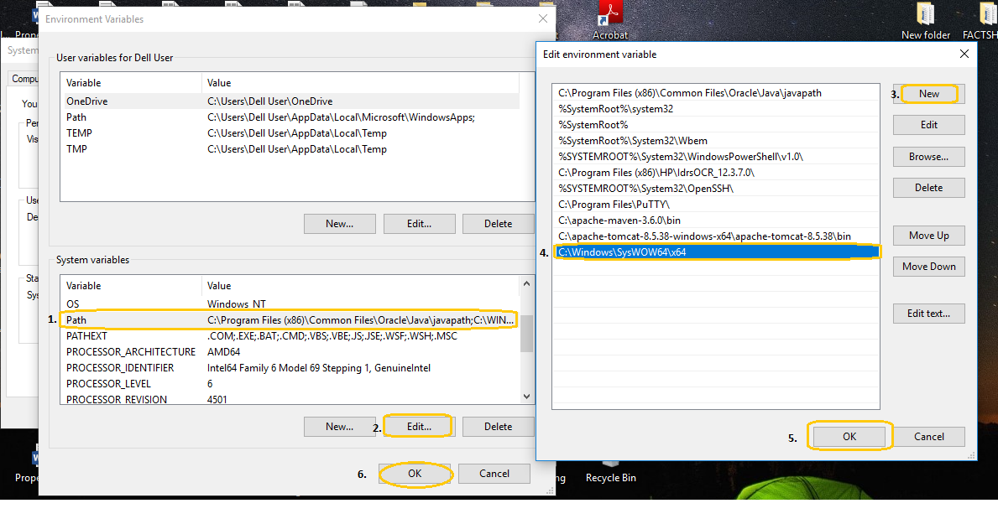

|  |  |
| --- | --- |
| OS Architecture | Path |
| * 32 bits * 64 bits | * C:\windows\system32 * C:\windows\SysWOW64 |

**Step 3. Install and configure biometric service.**

* Copy NMRS-Biometric-deploy to preferred directory.
* Edit the configuration file. The configuration folder contains a configuration file named “applications.properties”.

Details of the configuration are outlined below

|  |  |
| --- | --- |
| Server.port | DO NOT MODIFY THIS. |
| App.server | Database server host. |
| App.dbname | openmrs database name. |
| App.username | Database username). |
| App.password | Database password. |
| App.dbport | Database server port. |

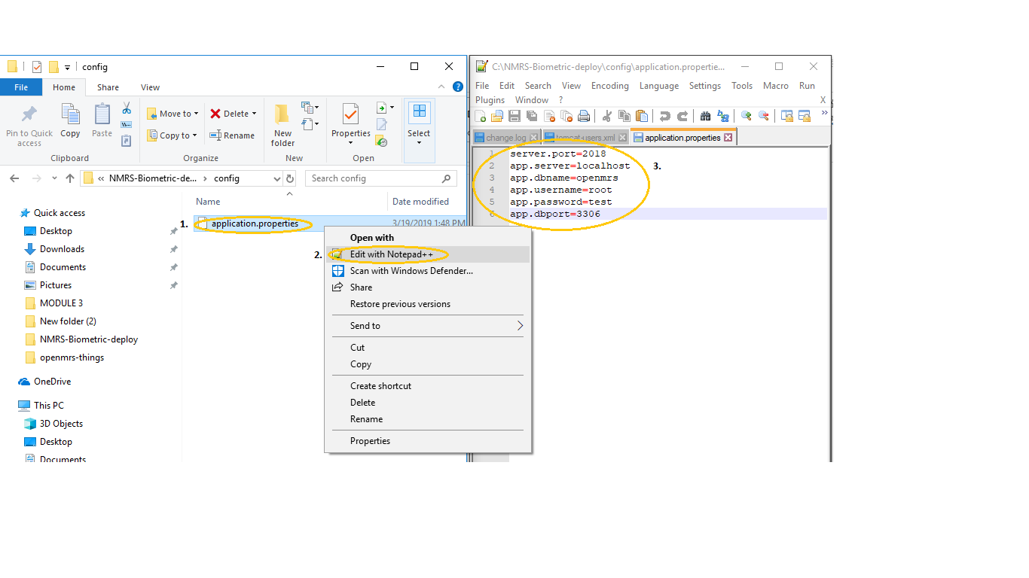

* Open command prompt as **ADMINISTRATOR**.
* CD to the NMRS-Biometric-deploy path
* Run NMRS-Bio.exe install.
* If the above command runs without errors, then the installation is successful, and the service should be available on windows services.
* Reboot computer system.

**Notes.**

* Switching USB ports will require biometric service restart.
* Avoid switching USB ports when fingerprint capture is in progress.
* Apply lotion/water on dry fingers, clean wet fingers to effective fingerprint capture.
* Ensure fingerprint capture devices are firmly connected to USB ports.